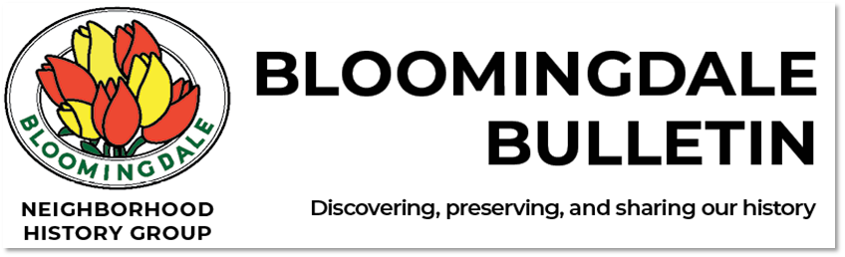

Issue No. 8 Fall 2022

A New Season!
Autumn in New York, a time so memorable songs have been written about it. Here’s the latest edition of Bloomingdale Bulletin with news of local events and neighborhood history of the Upper West Side between 96th and 110th Streets from Central Park to the Hudson River. The Bloomingdale Neighborhood History Group welcomes your feedback, comments, and ideas at our website, www.upperwestsidehistory.org.

Upcoming Programs

Homemade History Exchange – Fall Encore
Vita Wallace

Sunday, October 16, 2022, 1:00 pm - 4:00 pm
Amsterdam Avenue at 107th Street

Following the big success of the ﬁrst-ever Homemade History Exchange in August (see a summary below), there will be an encore opportunity to chat with neighbors and look through a select collection of historical photos, articles, maps, and other items related to the immediate neighborhood.
History Group volunteers will be there to help you research your building or your block, and to ﬁnd further resources. Bring your own historical photos or other items to share – we’ll be eager to see them!
The History Exchange is co-sponsored by the Bloomingdale Neighborhood History Group and the Columbus Amsterdam BID as part of the Open Streets program.

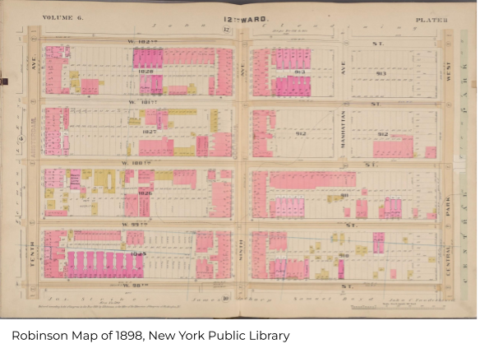
Free Walking Tours
Jim Mackin
Wednesday, October 19, 6:00 pm
Sunday, November 13, 2:00 pm
Sunday, December 11, 2:00 pm
Meet at the south end of Straus Park, Broadway and 106th Street

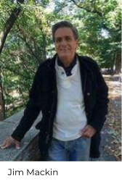
Fall is a great time for a walking tour of historic Bloomingdale. Tour guide Jim Mackin, a BNHG member, is a well-known NYC historian and author of Notable New Yorkers of Manhattan’s Upper West Side. His tours, rich with local neighborhood history, are hugely entertaining and no two are the same. Jim is also the founder of Weekday Walks, which offers tours every Wednesday morning, covering a different part of the city each time.

Building the Metropolis
Alexander Wood

Wednesday, November 9, 2022, 6:30 pm

In the late nineteenth century, New York’s rapid growth created a new urban landscape, turned construction into big business, and revitalized the building trades. Alexander Wood will turn the focus to building Bloomingdale as he covers technological changes that transformed construction, the importance of the building industry to the city’s economy, and the role played by contractors and construction workers in politics at the time.

Alexander Wood is an architectural and urban historian. He received his Ph.D. from Columbia University and his B. Arch from Cooper Union. In 2021-22 he was the Helen and Robert Appel Fellow in History and Technology at the New-York Historical Society.

This will be a free zoom presentation. Check our website for the link.

Riverside Park in Bloomingdale: A History
Stephanie Azzarone

Wednesday, November 30, 2022, 6:30 pm

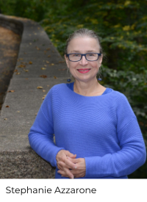
Riverside Park and Riverside Drive have lived many lives. Originally Native American hunting grounds, over time they were also the site of vast farms, elegant country estates, stunning millionaires’ villas, and skyscraping Art Deco treasures.

Stephanie Azzarone will focus on developments along the Park and Drive in the Bloomingdale neighborhood – the sights, stories, and people that make the area so special.

Stephanie Azzarone is the author of the new book Heaven on the Hudson: Mansions,
Monuments, and Marvels of Riverside Park, a
colorful tale of the neighborhood’s history, architecture, and people. A native New Yorker who has lived across from Riverside Park most of her life, Stephanie is a former journalist.

This will be a free zoom presentation. Check our website for the link.

Vanished Waters:

Recent Events

The Old Springs, Wells, and Watercourses of Bloomingdale
Jim Mackin and Gil Tauber

September 29, 2022

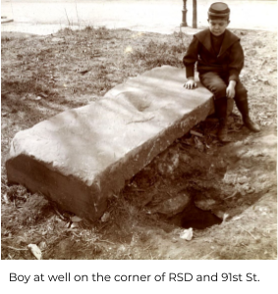
This delightful dip into the waters of Bloomingdale past revealed their remarkable importance to our neighborhood history.

Streams and ponds covered our landscape before the Dutch arrived. When the Croton Aqueduct (constructed between 1837 and 1842) came right through Bloomingdale, it changed the neighborhood
forever. Among many fascinating accounts is the one from about 120 years ago, when an interesting fellow, named James Ruell Smith, took his camera, got on his bicycle, searched out,
and documented every water spring and well in the area.

On the evening of this presentation, the BNHG presented its annual Jim Torain Award to Robert W. Snyder, Manhattan Borough Historian (see the story below).

You can see a recording of the program on our website.

Homemade History Exchange
Vita Wallace

Sunday August 14, 2022
Organized by Vita Wallace; co-sponsored by the Bloomingdale Neighborhood History Group and the Columbus Amsterdam BID

During the pandemic, it's been easier to stay in touch with long-time followers than to meet new people, so a welcome aspect of our recent outdoor in-person event was serendipity: Neighbors could bump into us

again. With the help of the Columbus Amsterdam Business Improvement District, the guardian angels of weekly Open Streets, we set up several tents
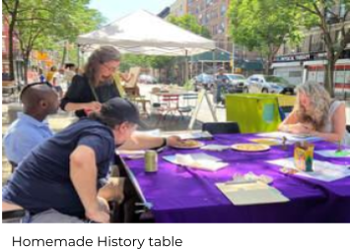
and tables on 109th and Amsterdam. It was a beautifully cool and sunny day.
You could browse display boards and pick up ﬂiers and maps to take home. Next to the ﬂier table was a “reading room,” a big square table. Upon the table were many paths into the history and our group’s 22 years of collected knowledge.

You could begin by looking up your address in Gil Tauber’s Building Database, then go on to read Pam Tice’s Blogs, pore
over materials from our Library Collection (chosen for their relevance to the block we were on), and read booklets from the collection on Fire Department history, our local subway stations, the Bloomingdale Conservation Project, the Manhattan Avenue Historic District, and How to Research Your Building, as well as Jim Mackin’s book, Notable New Yorkers of Manhattan’s Upper West Side. Readers enjoyed homemade cookies, took pictures of certain pages, and leant over to show each other especially interesting bits.

Another avenue into the history was to talk with the many members of our planning committee who were there. I highlighted the Lion Brewery (just because it was where we were sitting, and it’s invisible to the naked eye now!) and the brewery’s big ﬁre of July 4, 1927 (because it was spectacular, and we had a picture).

Peter Arndtsen, Columbus Amsterdam BID Manager, reported that the Homemade History Exchange “was a tremendously engaging event
that brought out and together a variety of the neighborhood!” In addition to passersby, a lot of folks came speciﬁcally for the event. A few brought materials for our library collection, but many others clearly brought knowledge to share.

A warm welcome to those of you who just joined our mailing list! As Win Armstrong of the BNHG remarked, the day was “both a catharsis and a stimulus.” May the lively exchange of knowledge continue, in a variety of happy forms!

2022 Jim Torain Award Presented to Robert W. Snyder
The Bloomingdale Neighborhood History Group selected Robert W. Snyder, Manhattan Borough Historian, as the recipient of the 2022 Jim Torain Award, in recognition of the impressive work he has done to help share and promote local history throughout Manhattan, and especially for the ideas and encouragement he has given to the BNHG. Win Armstrong, a founding member of the BNHG, made the presentation on September 29, 2022.

Robert W. Snyder is the Manhattan Borough Historian and professor emeritus of Journalism and American Studies at Rutgers University. He has devoted his
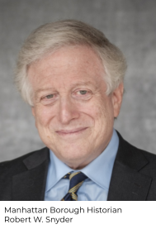
career to writing and teaching about the history of New York City. Currently editing a documentary history of the Covid pandemic in New York City, he has written for both scholars and the general public in books such as Crossing Broadway: Washington Heights and the Promise of New York and All the Nations Under Heaven: Immigrants, Migrants and the Making of New York.

To share history with a broad public, he has worked with the Smithsonian Institution, National Public Radio, and the Museum of the City of New York, and published essays in The New York Times, The Washington Post, The Conversation, and Platform. He was a Fulbright lecturer in American Studies in
Korea and is a member of the New York Academy of History. He lives in Manhattan.

Since 2018 (with a hiatus in 2020 for the pandemic), the BNHG has presented the annual Torain Award in honor of the memory of former member Jim Torain, who worked tirelessly to preserve the legacy of the Old Community where he grew up. The Old Community is the name given to the African
-American neighborhood that ﬂourished on West 98th and West 99th Streets between Central Park West and Columbus Avenue – a neighborhood that was destroyed in the mid-1950s as part of the city's urban renewal plan. Without Torain's work, the history of this vibrant neighborhood, once the home of so many talented and accomplished New Yorkers, might have been lost to time.

Heaven on the Hudson
BNHG Planning Group member and author Stephanie Azzarone has just published her new book, Heaven on the Hudson: Mansions, Monuments, and Marvels of Riverside Park. It’s the colorful tale of a singular New York City neighborhood and the personalities who make it special.

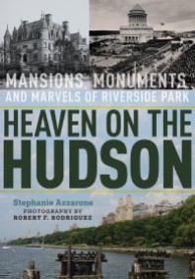
To outsiders or East Siders, Riverside Park and Riverside Drive may not have the star status of Central Park or Fifth Avenue. But here, at the city’s westernmost edge, there is a quiet and beauty like nowhere else in all of New York. There are miles of mansions and monuments, acres of ﬂora and fauna ranging from Peregrine falcons to goats. It’s where the Gershwins and Babe Ruth once lived, William Randolph Hearst ensconced his paramour, and Amy Schumer owns a penthouse.

Told in Stephanie’s uniquely personal voice as a long-time resident, Heaven on the Hudson is the only New York City book that features the
history, architecture, and people of this often-overlooked neighborhood, from the 18th century through the present day.

Published by Fordham University Press/Empire State Editions. Available at Amazon, Barnes & Noble, Book Culture, Shakespeare & Co., The Strand, and other local bookstores starting September 20. Retail price: $39.95.

75 Years Ago in Bloomingdale: Thanksgiving Dinner at the Hotel Marseilles
Pam Tice

As asylum seekers arrive in New York this year, we might want to remember a time 75 years ago when the Bloomingdale neighborhood welcomed World War II refugees in great numbers. The Hotel Marseilles at Broadway and 103rd Street was the temporary home for Jewish survivors from Europe.

United Service for New Americans, an organization supported by United Jewish Appeal, worked to help the refugees resettle in the United States,
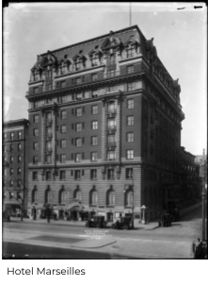
ﬁnding and linking them to family already here, providing introductions and supplies for resettling, and help in ﬁnding housing and a job. A Presidential Directive in 1947 allowed 39,000 refugees to enter the country. Newspaper reports announced the arrival of ships regularly, with refugees from the American-occupied zones in Germany and Austria. Several
human-interest stories helped build public sympathy, as families were reunited and orphans were met by new parents.

The reception center at the Marseilles could house 600 people, with most staying about two weeks. Each person was assigned a caseworker, as the organization had to report what action was taken for each person. Clothing and other supplies were provided, along with medical and
dental attention. Since many people would be sent on to other American cities, staff at the Hotel displayed photos and facts about these places that were unknown to the Europeans.

On November 25, 1947, a Thanksgiving Dinner was enjoyed by the residents, along with a welcoming speech by Commerce Secretary W. Averell Harriman. Our thanks to Landmark West, which recently published an excellent article about the history of the Hotel Marseilles by Tom Miller. Here’s a link.

An Upper West Side Notable
From Notable New Yorkers of Manhattan’s Upper West Side
by Jim Mackin
Fordham University Press

Colson Whitehead (1969 - )
Novelist
221 West 105th Street

Although Brooklyn can now claim Whitehead, one of the greatest living novelists in the country grew up in our Bloomingdale neighborhood. He has won two Pulitzer Prizes: one for his novel The Underground Railroad and the other for The Nickel Boys. If his John Henry Days had also won, instead of just

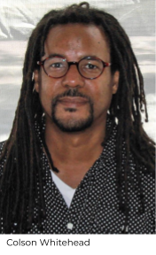
achieving ﬁnalist status, he would have set a record. His most recent novel, Harlem Shufﬂe, is receiving much attention.

All of his eight novels have received awards and he has earned a McArthur Fellowship, a Guggenheim Fellowship, a Harvard Arts Medal, and the Library of Congress Prize for American Fiction. He has also rendered two non-ﬁction books and numerous articles in The New Yorker, The New York Times, and other publications that are fortunate to have his talents.
After attending the nearby Trinity School, Whitehead graduated from Harvard in1991. When not writing, he teaches at New York University, Columbia, Princeton, and other universities. Vassar College and the Universities at Richmond and Wyoming had him as
Writer-in-Residence. Might a movie version of a Colson Whitehead novel be in the works?

Place Names in Bloomingdale
By Batya Miller and Nancy Macagno
These are two new additions to a series explaining place names in Bloomingdale.

Duke Ellington Boulevard

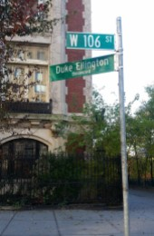
Do you ever wonder why West 106th Street from Riverside Drive to Central Park is called Duke Ellington Boulevard? The answer lies in two townhouses with a lot of history.

Born in 1899 to a musical family in Washington, D.C., Edward Kennedy Ellington was given the nickname Duke by childhood friends because of his dapper dress and noble bearing, and it stuck. He moved to Harlem in 1923, was an important musical ﬁgure in the Harlem Renaissance, and is now considered one of the best known and most inﬂuential jazz musicians of all time. He is

credited with composing thousands of scores and led his popular jazz band for more than 50 years.

Ellington lived his ﬁnal years in Manhattan at 935 St. Nicholas Avenue in Washington Heights, now known as The Duke Ellington House, a National Historic Landmark. Less well known is his connection to two adjacent townhouses on Riverside Drive just south of 106th Street.

In the 1950s, he purchased 334 Riverside Drive, where his sister, Ruth Ellington James, lived with her family. A few years later, he bought the next-door building, 333 Riverside Drive. This became the ofﬁce of his music publishing company, Tempo Music, run by Ruth. There is a question as to whether Duke ever actually lived there, his family saying he never even spent the night.
However, during the 1950s and 1960s, he spent time at the location composing music and it became a lively weekend jazz venue. Ellington later gave 334 to his son Mercer, who sold it in 1975, and he gave 333 to Ruth, who sold it in 1980.

Duke Ellington died on May 24, 1974, at age 75. His funeral, which drew more than 12,000 people, took place at St. John the Divine. In December of 1977, West 106th Street was ofﬁcially renamed Duke Ellington Boulevard. The selection of the site was the result of a negotiation between the Duke Ellington Society, who wanted a location closer to Lincoln Center, and the city, which preferred a small street in Harlem.

Humphrey Bogart Place

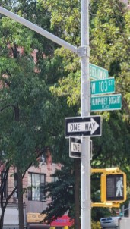
On June 24, 2006, the New York City Housing Authority named the block of 103rd Street between Broadway and West End Avenue Humphrey Bogart Place in honor of the legendary actor who grew up at 245 West 103rd Street.

The stately four-story townhouse was purchased in 1898 by his parents, Belmont DeForest Bogart and Maud Humphrey. Young Humphrey lived there from the time of his birth in 1899 until 1923, by which time his acting career was launched.

Born to wealth and a distinguished lineage (father was descended from a Dutch settler; mother traced her lineage to the Mayﬂower), he had a pampered and privileged childhood at a time when the neighborhood was considered quite fashionable. He

achieved early fame as a baby when his mother, a successful illustrator with her studio in the townhouse, used him as a model in a national advertising campaign for Mellin’s Baby Food. She dressed him in Little Lord Fauntleroy outﬁts that she made by hand, which resulted in teasing by classmates about his “sissy image.”

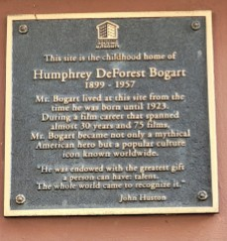
Humphrey went to Trinity School (founded in 1709 to provide education to the poor) on West 91st Street. He was an indifferent student and his father hoped to shape him up by sending him to his alma mater, the Phillips Academy in Massachusetts, where he was expelled after a year of “idle behavior.” This was followed by a stint in the navy and then, in 1921, he headed to Broadway to try his hand at the theater.

The city Housing Authority block dedication ceremony was attended by Bogart’s widow, Lauren Bacall. A plaque afﬁxed to his childhood home was unveiled at the event.

Bloomingdale’s Orphan Houses
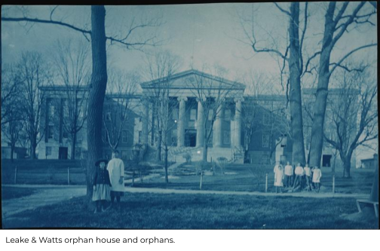

Starting in the middle of the 19th century, our rural Bloomingdale neighborhood was chosen by numerous philanthropic organizations as a good place to build orphan houses. New York City’s rising population of economically poor immigrants, along with rampant disease, created many broken families who could not care for their children.

Pam Tice explores the orphan house sites in a new blog post available at our website.

The Bloomingdale Neighborhood History Group promotes research and education about the history of the Bloomingdale neighborhood, and we are available as a resource. We share our ﬁndings through free public programs, walking tours, workshops, publications, a blog, our website, www.upperwestsidehistory.org, and a Neighborhood History Collection of materials housed at the Bloomingdale Branch of the New York Public Library, 150 West 100th Street.

